This document contains information proprietary to Sumitomo Corporation Global Tubular Solutions LLC, and may not be reproduced, disclosed or used in whole or part without the express written permission of Sumitomo Corporation Global Tubular Solutions LLC.
© 2009 Sumitomo Corporation Global Tubular Solutions LLC

Disable Java out-of-date popup

Authors: Stephen George
Date: 06-Jul-16
Last Reviewed:
Reviewer:
Location: Houston, TX

Revision History
Revision Number | Revision Date | Revision Author |  | Revision Approval
1.0 | 06-Jul-16 |  | Stephen George

Contents
1 Objective 0
2 Disable Java out-of-date popup 0
2.1 Create java deployment folder 0
2.2 Copy the attached files 0
2.3 Update registry 0
2.4 Clear Java Cache 0
3 Contacts 0

Objective
The objective of this document is to show users how to disable the Java out-of-date popup that appears periodically when accessing ITIMS2 application

Disable Java out-of-date popup

Create java deployment folder
On your computer, check to see if the folder structure “C:\Windows\sun\java\deployment” exists. If not please create it.
Note: Please contact your system administrator if you don’t have permission to create the folder

Copy the attached files
Please copy the below two files under the folder “C:\Windows\sun\java\deployment”. The files can be copied by selecting the individual file and pasting them into the folder

Update registry
Open a command prompt with administrator permission. The steps for Windows7 and Windows 8 operating systems are listed below
On Windows 7:
Click Start and then Run
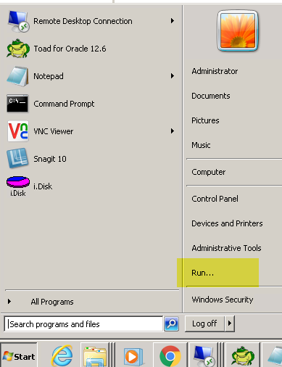

Type cmd and it should open an command prompt window as displayed below. Make sure the command prompt is opened with adminstrative privileges. You can do so by right clicking on the “Command Prompt” and choose “Run as administrator” option.
Note: Please contact your system administrator if you don’t have permission to run as administrator

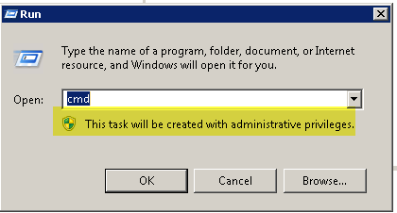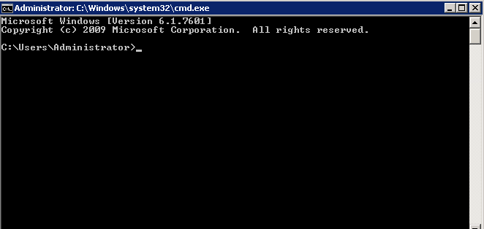

Type in the command “setx deployment.expiration.check.enabled false /m” and press enter; You will see a success message as displayed below
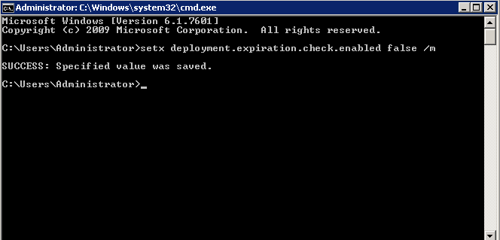

On Windows 8:
Click the Windows icon highlighted below
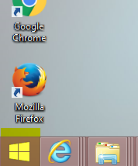
Click the search icon highlighted below
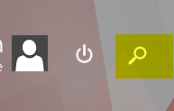
Type cmd in the search field
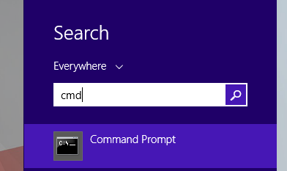
Right click on the “Command Prompt” and choose “Run as administrator” option
Note: Please contact your system administrator if you don’t have permission to run as administrator

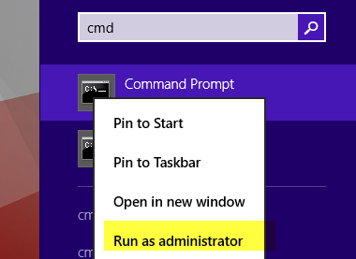
The below command prompt will be opened
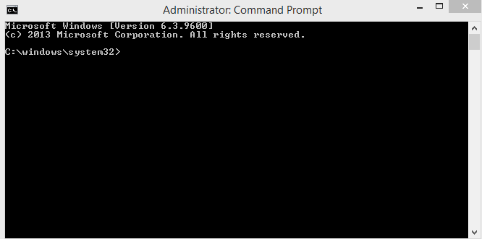
Type in the command “setx deployment.expiration.check.enabled false /m” and press enter; You will see a success message as displayed below
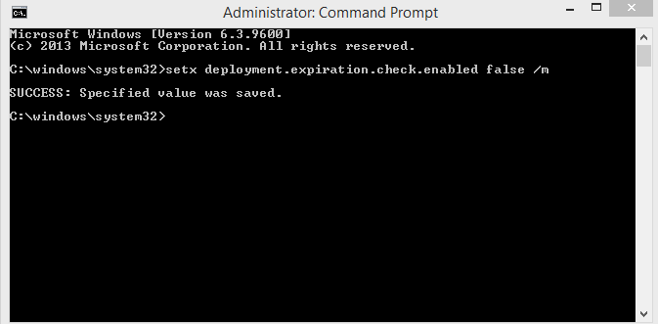

Clear Java Cache
Below are the steps to clear the Java Cache
On Windows 7:
Go to Control Panel |Java | General Tab | Temporary Internet Files > Settings…. > Delete Files… A popup with two item should be checked (Applications and Applets and Trace and Logfiles). Leave the items selected and click OK.
On Windows 8:
Go to Control Panel |Programs|Java | General Tab | Temporary Internet Files > Settings…. > Delete Files… A popup with two item should be checked (Applications and Applets and Trace and Logfiles). Leave the items selected and click OK.

Contacts
Please contact the SCGTS Helpdesk at helpdesk@scgts.com with any questions or issues.

