 | SC Global Tubular Solutions LLC  Three Memorial City Plaza, 840 Gessner Road, Suite 900  Houston, Texas 77024  Phone: 713.653.8489  Fax: 713.653.8488

Information Systems Group (ISG)

Issue Log User Documentation

Author(s) | Monicca Warjanto
Last Update | 10-JULY-2011
Document Version | 3.0
Status | Draft
Document Location

This document contains information proprietary to Sumitomo Corporation Global Tubular Services Limited, and may not be reproduced, disclosed or used in whole or part without the express written permission of Sumitomo Corporation Global Tubular Services Limited.
© 2011 Sumitomo Corporation Global Tubular Services Limited

Table of Contents
Introduction 6
Roles 7
Guest 7
User 7
Site Admin 7
Developer 7
Administrator 7
Main Report 8
CREATE button 8
Log ID link 8
Change Request Info 12
❖ Application 12
❖ Component Type 12
❖ Component Name 12
❖ Need Date 13
❖ Issue 13
❖ CREATE button 13
1. Display Issue 14
2. Additional Issue 15
3. UPLOAD button 15
4. Report of the uploaded document 15
CANCEL Button 16
APPLY CHANGES Button 16
Issue Info 17
5. ID 17
6. Status 17
❖ Tracking Progress 17
❖ Created By 17
❖ Created On 18
Detail Process Info 19
Subscription 20
Message Board 21
Documentation 22
❖ Program Change Notice Required Flag 22
❖ User Guide Required Flag 22
❖ Business Document Required Flag 22
CARDS 24
❖ Report Name 24
❖ Report Run ID 24
❖ Distribution list 24
❖ Cards Schedule 24
Site Admin Approval 26
Review 27
❖ Under Review checkbox 27
❖ Issue Class 27
❖ Component Type 27
❖ Component Name 28
❖ Finding 28
❖ Reviewed checkbox 28
Authorization 30
❖ Yes/No radio group 30
❖ Note 30
❖ Priority 30
❖ Emergency 30
❖ Assign To 30
❖ Set as “Public” 30
Design and Implementation 31
❖ Instruction 31
❖ Developer’s Plan 31
❖ Request for Approval 31
❖ Response to Assignee 31
❖ Yes/No radio button 31
❖ Work In Process checkbox 31
❖ Actions 31
❖ Manager Verification 31
Testing 35
❖ Existing Testing Plan and Result report 35
❖ CREATE NEW TEST button 35
❖ ID 35
❖ Prepared By 35
❖ Date 35
❖ Environment 35
❖ Test Case 35
❖ Test Steps 35
❖ Test Result 35
❖ UPLOADED button 35
❖ Uploaded Document report 35
❖ REQUEST FOR APPROVAL button 35
❖ Yes/NO radio button 35
❖ Response to Assignee 35
Deployment 39
❖ Deployed to TST checkbox 39
❖ User Testing Notification checkbox 39
❖ Email 39
❖ SEND EMAIL button 39
❖ IT DIR APPROVAL button 39
❖ Yes/No radio button 39
❖ Deploy By 39
❖ VERIFICATION REQUEST button 39
❖ Verify By 39
❖ Result 39
Code Review 41
❖ By 41
❖ Result 41
❖ Note 41
End User Confirmation 42
❖ By 42
❖ Date 42
❖ Note 42

Introduction

Issue Log is an application to manage, maintain and track the progress of issues submitted by users. Users here include all SCGTS employees and others who are using SCGTS supported applications.

Roles

There are five different user types: Guest, User, Site Admin, Developer and Administrator. Explanations on this document will consider these five types as some screens will look different among the different roles.

Guest - It has the least privilege on the IL application. Users who are granted with this role are only allowed to view the content of the IL. This type will be temporarily granted to auditors.

User - Users who are granted with this role are allowed to create/submit a new Issue, subscribe, post message, create and upload testing plan and result, and they can complete the End User Confirmation tab. This type will be granted to the majority of users.

Site Admin - Users granted with this role has an additional privilege compare the user type. They can update the Site Admin Approval tab. This type will be granted only to the site administrator of each site.

Developer - Users granted with this role are allowed to create/submit a new Issue, subscribe, post message, review the IL, submit their plan and actions, create and upload testing plan and result and complete the End User Confirmation tab. This type will be granted to ISG developers and systems administrator.

Administrator - Users granted with this role have access to all the IL tabs. In addition to access described above, users with Admin privileges can access Authorization, all necessary approvals and Deployment tabs. This type will be granted to IT Director and Managers.

Main Report

The main report lists all submitted issues. However, the list is limited only to application or applications that a user has permission to. For example, if user John Smith, JSMITH, only has access to itims2 application Baku site (iTIMS2-BAK), he sees only issues submitted under iTIMS2-BAK.

CREATE button
A CREATE button is to create/submit a new issue. It is visible for a user whose role is User, Site Admin, Developer or Administrator.

Log ID link
The Log ID is a link to drill down to the issue’s details. The link is available for all type of users.

As default, there are ten (10) columns displayed on the report. However, there are more columns available for users to select when creating their own reports. Click the Actions button –> Select Columns. See figure 1. Box on the right lists all columns that have been displayed on the report. Box on the left contains list of columns that users can add to the existing report. Users can remove or add columns using navigation on the middle
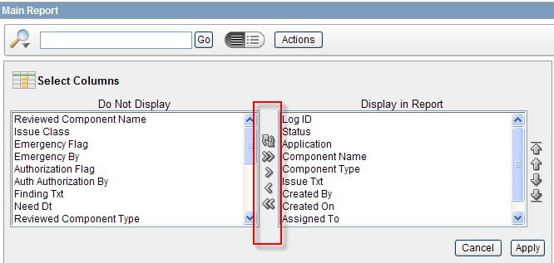
Figure 1 – Select Columns

The following are screen shots of how the main report looks for different types of users.

- User/Site Admin/Developer
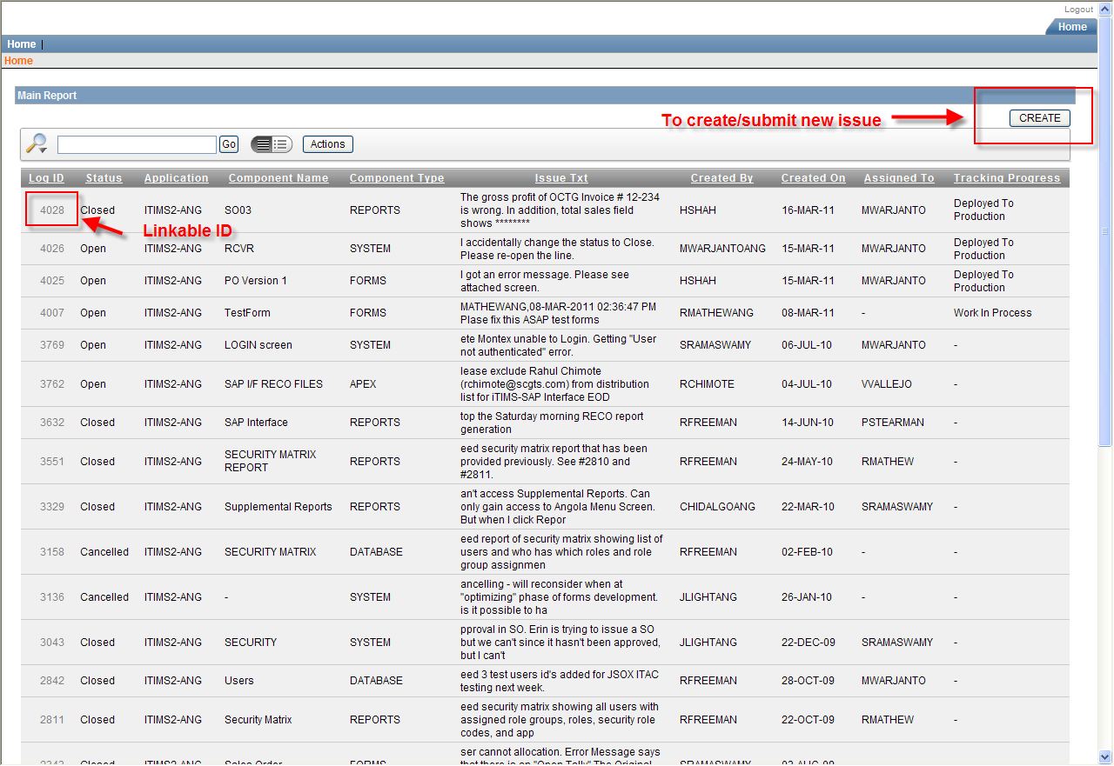
Figure 2 – User/Site Admin/Developer
- Administrator
If user login as an Administrator, he will see the second tab, Administration tab, appeared on the main report page.
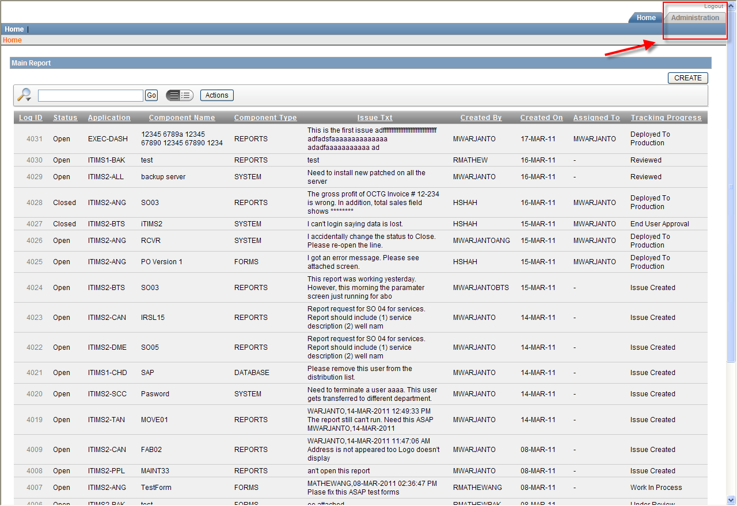
Figure 3 - Administrator
- Guest
If user logs in as a Guest, he will only have access to the linkable ID. See below figure.
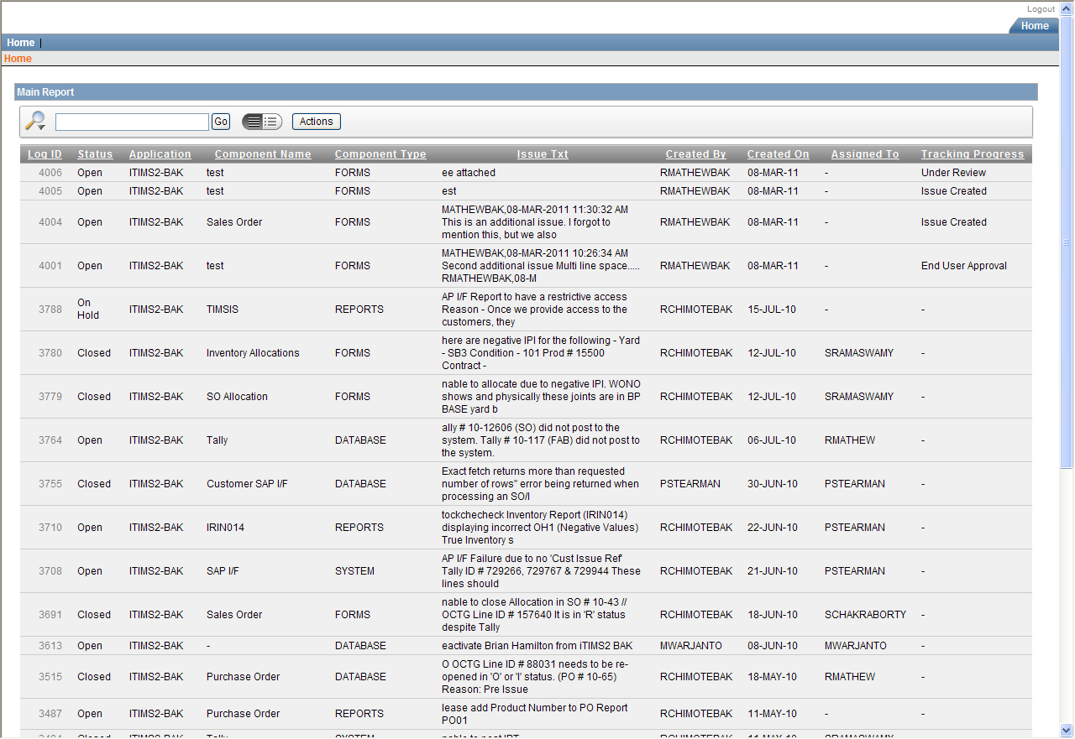
Figure 4 - Guest

Change Request Info

It is the main form to enter the information regarding the issue.
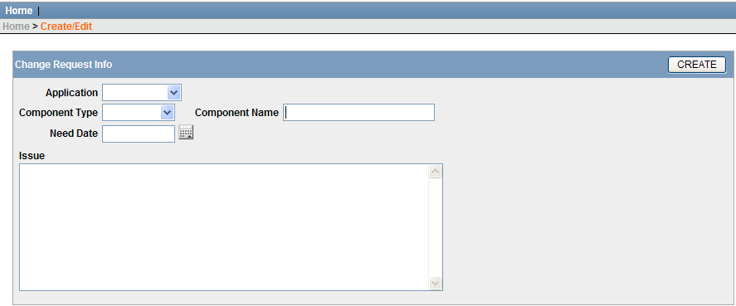
Items
- Application – It lists the application or applications that have been assigned to a user. Hence some user might see only one application while others might see more than one application. This item is required to be completed.
- Component Type – It lists type of issue. This item is required to be completed. There are five (5) available options
  - APEX – Select this option when user has issue with report’s parameter page.
  - CARDS – Select this option when user wants to set up CARDS report job.
  - DATABASE – Select this option when user has issue with the data itself. For example, user enters wrong tally quantity or user needs the Invoice’s status change from Close to Issued.
  - FORMS – Select this option when user has issue with data entry type of module. For example, Purchase Order (PO) form in iTIMS2 application or Creating a new HSE Observation in HSE application.
  - REPORTS – Select this option when user has issue with the data presentation. For example, INVTYR01 report in iTIMS2 application or TRIN001 report in TIMSIS2 application.
  - SYSTEM – Select this option when user has issue with network connection or hardware. For example, user’s connection to iTIMS2 keeps dropping off or the server machine is suddenly shut off.
- Component Name – It is an area for user to specify the exact component that he has issue with. For example, if user selects FORMS on the component type select list, he should jot down the name of the forms, such as PO form. This item is required to be completed.
- Need Date – User can identify when the issue or requested change should be completed
- Issue – It is an area where user describes what the problem is. User can type up to 4000 characters.
- CREATE button – There are several processes occur after user clicks on the CREATE button.
  - Inserting a new issue to the database
  - Sending a notification email to several designated ISG personnel: IT Director, IT Managers and Help Desk personnel. Below figure shows the example of the notification email.
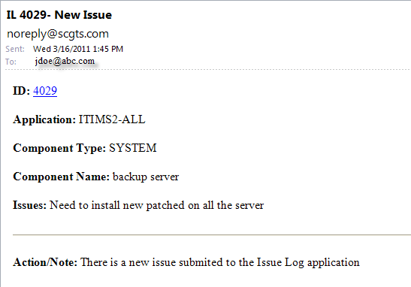
After user clicks on the CREATE button, the system will automatically take the user back to the same page. Additional information will appear, see below figure.
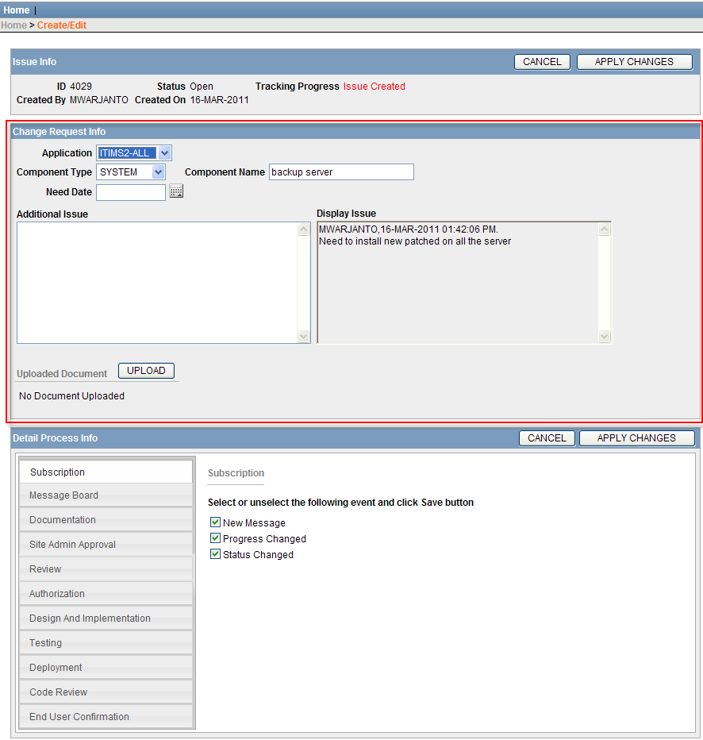
There are two new sections appeared: Issue Info and Detail Process Info. Both sections will be discussed in later sections.
New Items on Change Request Info
- Display Issue – Original issue text will be appeared on the Display Issue section with creator’s username, date and time append on top

- Additional Issue – Area to put additional issue text. Click the APPLY CHANGES button to submit the additional issue text. See below figure. Creator of the additional issue text, date and time will be appended on the top of the text.

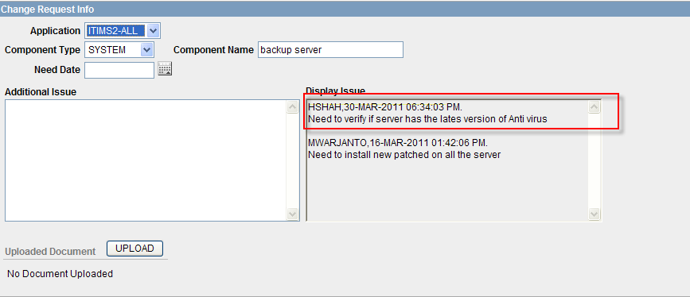

- UPLOAD button – This button will open the download window. See below figure. User can upload five documents at one time.
  - File Name – will be populated with the path of the uploaded file once user clicks on the Browse button.
  - Search Keys – field to enter the search keywords
  - Description – field to enter description about the uploaded file.

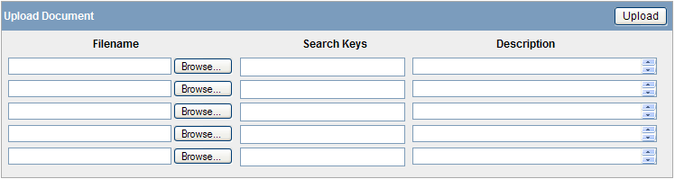

- Report of the uploaded document
See figure below. For each uploaded document, user has three options.
  - View – Option to view or to save the document to user’s local machine.
  - Edit – Option to edit the search keys and description
  - Delete – Option to delete the document along with its search keys and description
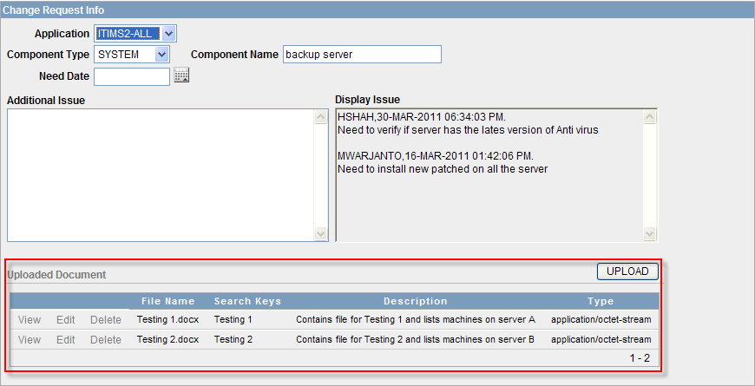

CANCEL Button

There are two CANCEL buttons on the main page. They both have identical functions and purposes. They are placed twice on the screen for convenient purpose, especially when user is dealing with long contents. It will take user back to the main report and will not save any change made.

APPLY CHANGES Button

There are two APPLY CHANGES buttons on the main page. They both have identical functions and purposes. They are placed twice on the screen for convenient purpose, especially when user is dealing with long contents. It will save all the changes made, except messages on the Message Board section.

Issue Info

This section displays quick information regarding the submitted issue, such as who was the originator, and when the issue created. For most users, all items are in read only mode, except Status item which is allowed to be updated by IT Director or IT Managers.

Items

- ID – This is a system generated id.
- Status – This item can be updated only by IT Director or IT Manager. There are four different status:
  - Open – Default status when user submits a new issue.
  - Closed – Indicates issue has been resolved and completed.
  - Cancelled – Indicates issue has been rejected to be worked on.
  - On Hold - Indicates issue has been put on hold until all necessary information is collected.

Tracking Progress
- Issue Created – When the issue was initially created.
- Site Admin Approval – After site administrator provides his approval.
- Under Review – After ISG member starts reviewing the submitted issue.
- Reviewed – After ISG member completes reviewing the submitted issue.
- Not Approved – When IT Director or IT Managers do not authorize the submitted issue to be worked on.
- Approved (Pending Assignment) – When IT Director or IT Managers authorize the submitted issue to be worked on.
- Assigned – When IT Director or IT Managers assign the submitted issue to any ISG members.
- Work In Process – When the assignee (ISG members) is working on the submitted issue.
- Ready for Testing – This progress will might appear if the issue requires any update or modification on existing applications, like iTIMS2 forms or reports. The progress means that the application is available in TESTING environment.
- Require User Testing – When other than assignee are notified to test the modified application.
- Deployed To Production –When the modified application has been pushed or rolled out to PRODUCTION environment.
- End User Approval – When end user has provided his confirmation
- Created By – Identifies the creator or originator of the issue

- Created On – Identifies the date when the issue was created

Detail Process Info

This section contains in depth information about the works or actions that have been done on the submitted issue, such as the assignee’s name, what is the assignee’s plan to solve the issue and when the assignee starts working on the issue. The information is organized in different set of tabs. Each tab is discussed in more detail on different sections.

Tabs

- Subscription
- Message Board
- Documentation
- Site Admin Approval
- CARDS
- Review
- Authorization
- Design And Implementation
- Testing
- Deployment
- Code Review
- End User Confirmation

Subscription

This section allows users to sign up for getting an automate notification when certain events occur. One user cannot sign up for other users. Users can change their subscription anytime. It is recommended that the originator of an issue subscribes to all events, so he will be up to date with the progress of the issue.
Events
- New Message – If this option selected, subscriber will receive a notification email every time new message is posted.
- Progress Changed – If this option selected, subscriber will receive a notification email every time a tracking progress changes.
- Status Changed – If this option selected, subscriber will receive a notification email every time status changes.
Instructions

To Subscribe
- Select the event(s)
- Click the APPLY CHANGES button

To Unsubscribe
- Unselect the event(s)
- Click the APPLY CHANGES button

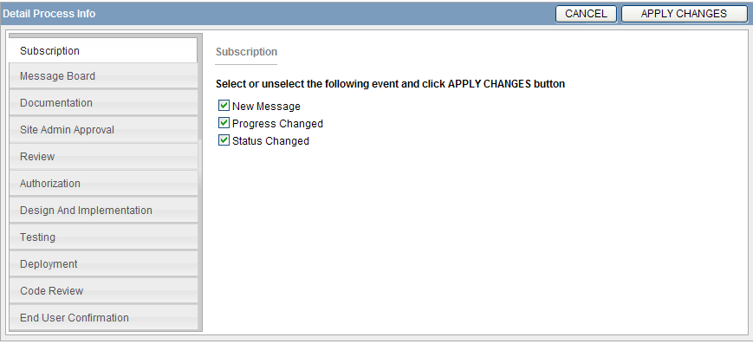

Message Board

This section serves as an online discussion section where users can exchange conversations in the form of posted messages. The message will be retained permanently. Once a message posted, the information of the message’s creator, date and time of the posted message will be appended on the top of the message. See below figure. In addition, a notification email will be sent to users who subscribe to the New Message event of a particular IL.

Instructions

- Type message on the Message text area
- Click the POST button, NOT the APPLY CHANGES button.

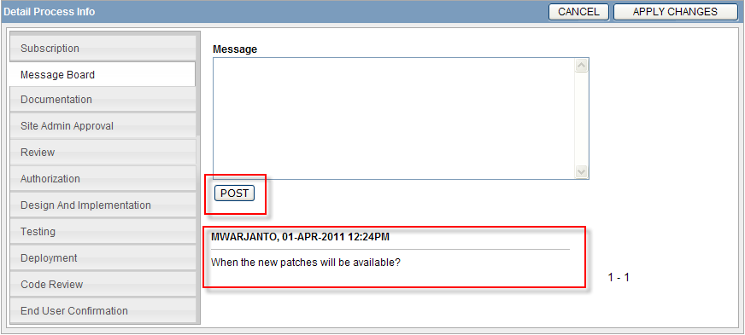

Documentation

The purpose of this section is to identify if certain existing documentations should be updated or new documentations should be added as the result of this IL. This section has two parts. The first part, Completed by ISG, is accessible to IT Director and IT Managers. The second part, Completed by OPS, is accessible to IT Director, IT Managers, Jeby George and Saurabh Vaidya. For others, this section is in Read Only mode.
Items
- Program Change Notice Required Flag – “Yes” means require an update on the existing design document or if none available, a new document should be created.
- User Guide Required Flag – “Yes” means require an update on the existing user guide document or if none available, a new document should be created.
- Business Document Required Flag - “Yes” means require an update on the existing business related document, such as training manual or if none available, a new document should be created.
Instructions
- Change the Flag values to “Yes”. If “Yes”, the Completed select list will be appeared.
- Select the Completed. It is defaulted to “No”.
- Click on APPLY CHANGES button
Screen layout
- Screen for permitted users
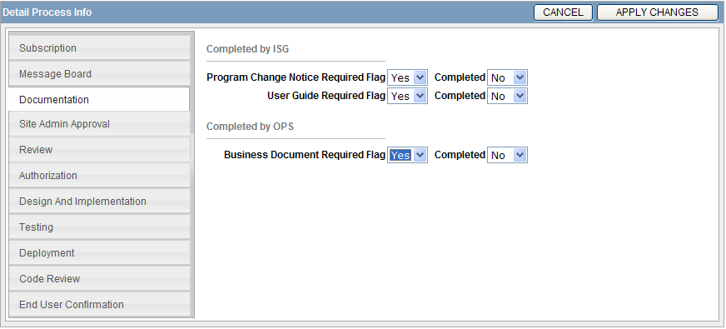
- Screen for non-permitted users

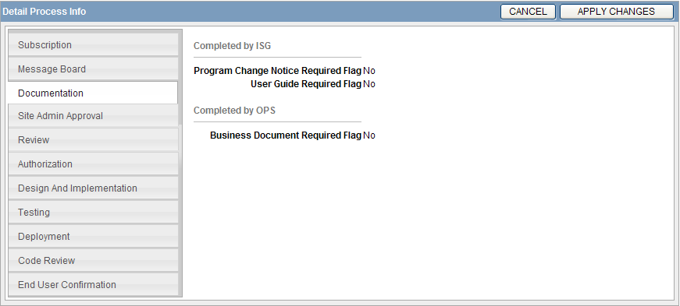
CARDS

The purpose of this section is to identify required information to set up a job in Customize Automated Report Delivery System (CARDS). This section is only available if the selected component type is CARDS.
Items:
- Report Name – To document the report’s name, such as INVTRY01 or FCST01. Only one report is allowed.
- Report Run ID – To document the report’s run id. Every time a report is executed, a new report’s run id is created. The report’s run id associates the parameter values with the specific report run.
- Distribution list – To document email addresses of users who will receive the report. Multiple emails are separated by comma.
- Cards Schedule – To document the frequency of running the reports, such as daily, weekly or monthly.
Instructions:
- Identify name of the report and enter it in the Report Name field.
- Run the report with the parameters that should be applied to the CARDS job. Then, capture the report’s run id and enter it in Report Run ID field.
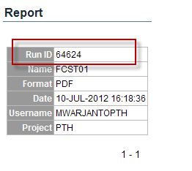
- Identify email addresses of report’s recipients and enter it in the Email Recipient(s) field.
- Identify the frequency and enter it in the Schedule field. For example, Daily, AM, Monday through Friday.

The following is list of reports that can be set up on CARDS. However, several reports only can be run on certain parameters’ condition.
Report Name | Condition
FCST01 | Status: Open or Issued
INVTRY01 | NONE
INVTRY02 | NONE
INVTRY05 | Date Type: Doc Date  Status: Open or Issued
INVTRY07 | NONE
XFR02 | Status: Open or Issued
FAB02 | Status: Open or Issued
ZEROADJ01 | NONE
SO03 | Date Type: Doc Date
SO04 | Status: Open or Issued
SO08 | Date Type: Doc Date  Status: Open or Issued
CR03 | Date Type: Doc Date  Status: Open or Issued
CR04 | Date Type: Doc Date  Status: Open or Issued
INVC04 | NONE
INVC08 | NONE
QUOTE01 | Parameter Option: BY OTHERS  Status: Open or Issued
PO06 | Status: Open or Issued
RCVR02 | Status: Open or Issued
MR02 | Status: Open or Issued

Site Admin Approval

This section is accessible only to site administrator of the site where the issue occurs and ISG members. The purpose of this section is to document site administrator’s approval and awareness of the reported issue. Site administrator’s username and date of approval are retained. See below figure.
Instructions
- Select the approval option. If “Yes”, site administrator’s username and date will be automatically populated
- Click the APPLY CHANGES button
- If completing the Site Admin Approval is the latest activity, the Tracking Progress will be changed to “Site Admin Approval.”

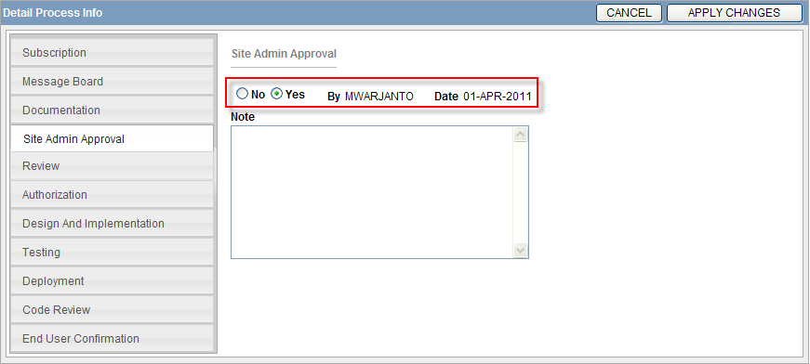

Review

This section is accessible to ISG members. The purpose of this section is to document the result of further investigation about the reported issue. In addition, the correct issue classification must be determined as well.
Items
- Under Review checkbox – To document who performs the reviewing process.
- Issue Class – Issue Classification. It is a required field as some buttons and processes are executed based on the selected classification.
  - Bug – Selected if there is an error on an existing application
  - Enhancement – Selected if there is a need to add new functionality on an existing application
  - Direct Data Changes Business – Selected if requires a direct change on production data. Here, data refers to values that associate with the business, and in most cases are entered or modified by users or the result of calculation performed on data entered by users such as Gross Price, SO quantity, receiver total or PO status.
  - Direct Data Changes Systems – Selected if requires a direct change on production data. Here, data refers to values that associate in maintaining the system. For instance, sequences, req_id, hdr_id or other values that are maintained by DBA group, such as values in APP_CTRL module.
  - Performance – Selected if submitted issue deals with system’s performance: slow query/sql, or servers. For example, user takes longer time to query records in iTIMS2 BAK TST PO module.
  - Redirect – Selected if submitted issue has been logged in another Issue Log record.
  - Summary – Selected if submitted issue is not an issue, but it is a summary list of tasks that are detailed in other Issue Log records. For example, IL 2345 contains a list of actions in which each action is addressed in different IL.
  - Systems – Selected for other issues that are related with systems and cannot be categorized under the existing issue classes.
  - User Error – Selected if the submitted issue doesn’t require any action from ISG. It occurs because user’s lack knowledge of the systems.
  - Other – Selected if submitted issue cannot be categorized under any existing issue classes.
- Component Type – Component type of the involved issue. Some options are similar to ones shown on the Change Request Info section, but there are additional options to select. Reason why component type select list also appears on the review section is to enable ISG members to categorize the submitted issues into correct type. Additional types:
  - APEX – Select this option when user has issue with report’s parameter page.
  - CARDS – Select this option when user wants to set up CARDS report job.

  - DATABASE – Select this option when user has issue with the data itself. For example, user enters wrong tally quantity or user needs the Invoice’s status change from Close to Issued.
  - FORMS – Select this option when user has issue with data entry type of module. For example, Purchase Order (PO) form in iTIMS2 application or Creating a new HSE Observation in HSE application.
  - NETWORK – Selected if submitted issue is regarding switching, routing or cabling.
  - INFRASTRUCTURE - Selected if submitted issue is regarding network design, implementation, appliances configuration or maintenance.
  - SERVER – Selected is submitted issue is specifically deal with servers.
  - SOFTWARE – Selected is submitted issue regarding installing new or updating users’ software, such as Microsoft office update.
  - UPDATE – Selected is submitted issue is about server or systems software update, such as database update, or visual cron update.
  - QUERY – Selected if the submitted issue requires ISG member to query some data and dump the result into certain type of output, such as deliver the data dump of all active users and their assigned roles in BAKU site.
  - REPORTS – Select this option when user has issue with the data presentation (reports). For example, INVTYR01 report in iTIMS2 application or TRIN001 report in TIMSIS2 application.
  - SYSTEM – Select this option when user has issue with the systems and issue cannot be categorized under existing categories.
  - SAP I/F – Selected if the submitted issue deals with SAP Interface.
  - OTHER – Selected if the submitted issue cannot be categorized under existing options.
- Component Name – Component name of the involved issue. Reason why this field appears on the review section, so ISG members can select the correct type.
- Finding – Area to document what are the cause of the submitted issue
- Reviewed checkbox – To document who completes the reviewing process. This field triggers the notification emails to inform IT Director and IT Managers to do the authorization process.
Instructions
- Click on the Under Review checkbox so other fields are editable
- Complete the other fields
- Click on APPLY CHANGES button
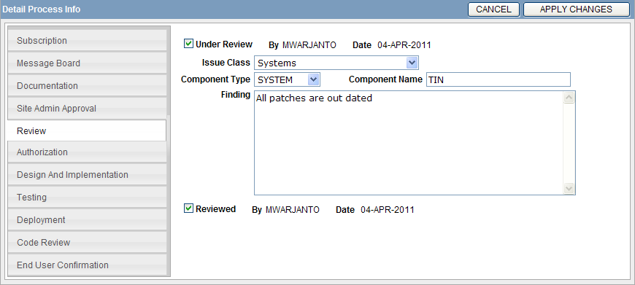

Authorization

This section is accessible to IT Director and IT Managers. The main goals of this section are to document IT Director’s or IT Managers’ approvals and to identify which ISG member that is assigned to work on the issue. See below figure.

Items

- Yes/No radio group – To document the approval. The approval’s username and date/time of the approval are automatically populated.
- Note – Area to jot down approval’s note.
- Priority – The level of severity of the submitted issue. It is defaulted to level 5.
- Emergency – To document if the submitted issue is categorized as an emergency type of issue.
- Assign To – To document the assignee. It triggers an automated email notification to inform assignee if the IL is assigned to him.
- Set as “Public” – This is not in used presently.

Instructions
- Complete the fields
- Click on APPLY CHANGES button

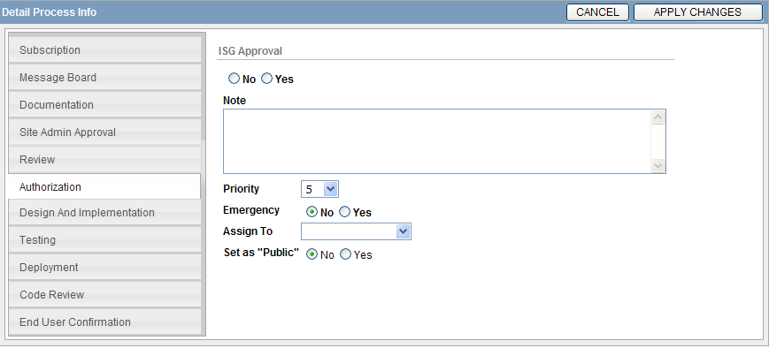

Design and Implementation

This section is accessible to ISG members. The main purpose of this section is to document IT Director’s or IT Managers’ further instruction on how to implement the solution for the submitted issue. In addition, assignee’s plan and actions are documented here as well.

Items

- Instruction – Area to write down further instructions on how to implement the fix for the submitted issue.
- Developer’s Plan – To document assignee’s plan to fix the issue.
- Request for Approval – This button is available to ISG members whose roles are not Administrator, IT Managers. This button is to request IT Managers’ approvals for the proposed plan.
- Response to Assignee – This button is available to ISG members whose roles are Administrator, IT Managers. This button is to send notification to the assignee after approval is made.
- Yes/No radio button – To document IT Managers’ approvals.
- Work In Process checkbox – Should be selected when the assignee starts working on the issue.
- Actions – Area to write down the actions taken by assignee to address the issue
- Manager Verification – This button is available only when the issue class is Systems. This button is to send an email to IT Managers to ask them to verify the completed job. Reason for this logic is because most of the systems changes have to be performed directly on PROD environment, so there is not testing environment available.

Instructions
- Complete the fields
- Click on APPLY CHANGES button
Screen’s layouts

  - For ISG members that have not Administrator role and issue class is Systems
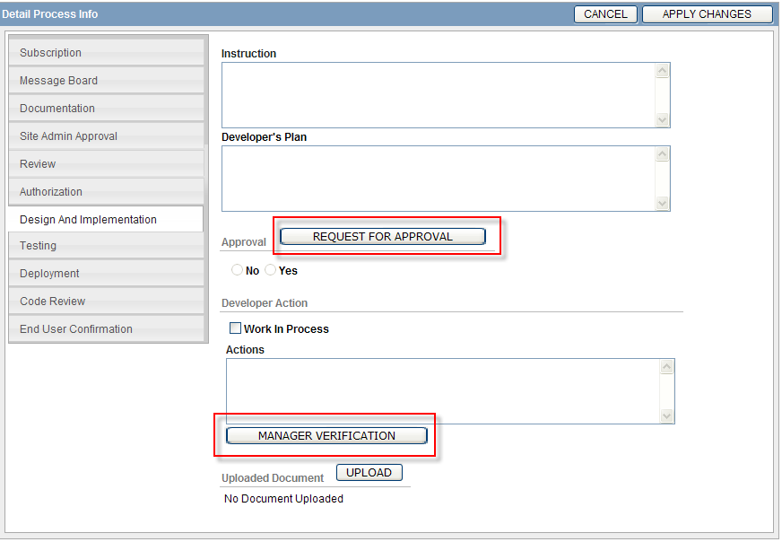

  - For ISG members that have not Administrator role and issue class is not Systems
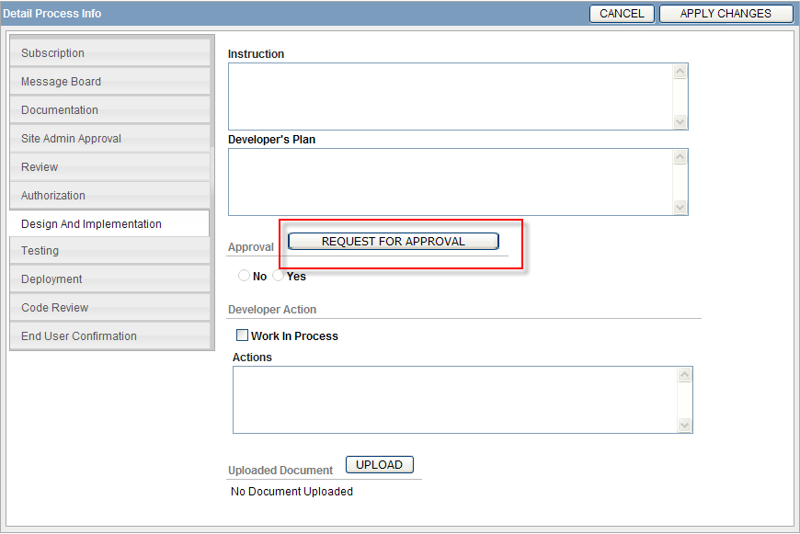
  - For ISG members that have Administrator role

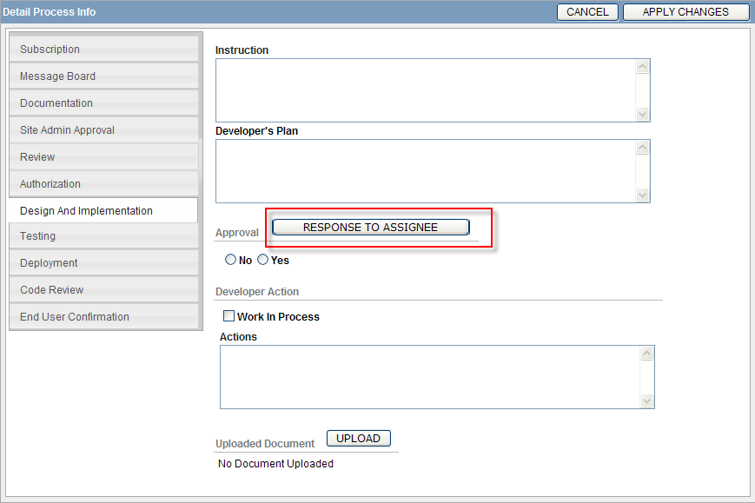

Testing

This section is accessible to all users except Guest type of users. The purpose of this section is to document testing plan, result and IT Director or IT Managers’ approvals if required. If testing plan and result is created by ISG members, then IT Director or IT Managers’ approvals is a must.

Items

- Existing Testing Plan and Result report – List of all existing tests for the particular Issue Log ID.
- CREATE NEW TEST button – To clear the form and create new test plan.
- ID – It is a read only field. It shows the Test Plan ID.
- Prepared By – To identify who prepares and executes the testing
- Date – To identify when the plan is prepared. It is automatically filled when the prepared by field is completed.
- Environment – To identify in which environment the test is executed, such as BTS – DEV.
- Test Case – Area to write down all possible test cases.
- Test Steps – Area to write down the steps to perform the test.
- Test Result – To indicate the testing result.
- UPLOADED button – to upload the document that contains testing result. The button is available after testing plan in created
- Uploaded Document report – To display all related uploaded document of particular test id.
- REQUEST FOR APPROVAL button – This button is available to ISG members whose roles are not Administrator, IT Managers. It is to request IT Managers’ approvals of the completed testing plan.
- Yes/NO radio button – To document IT Managers’ approvals.
- Response to Assignee – This button is available to ISG members whose roles are Administrator, IT Managers. This button is to send notification to the assignee after approval is made.

Instructions
For the first Testing plan
- Complete the necessary fields
- Click the APPLY CHANGES button
- Click the UPLOADED button to upload testing result
For additional Testing plan
- Click on CREATE NEW TEST button if form has some values already
- Complete the necessary fields
- Click the APPLY CHANGES button
- Click the UPLOADED button to upload testing result
Screen’s layouts

- ISG members other than ADMINISTRATOR
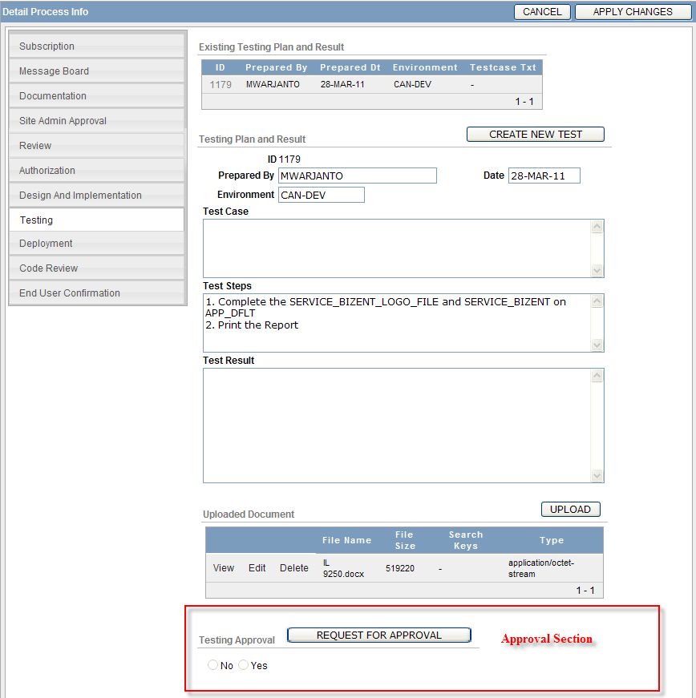

- ISG members with ADMINISTRATOR privilege

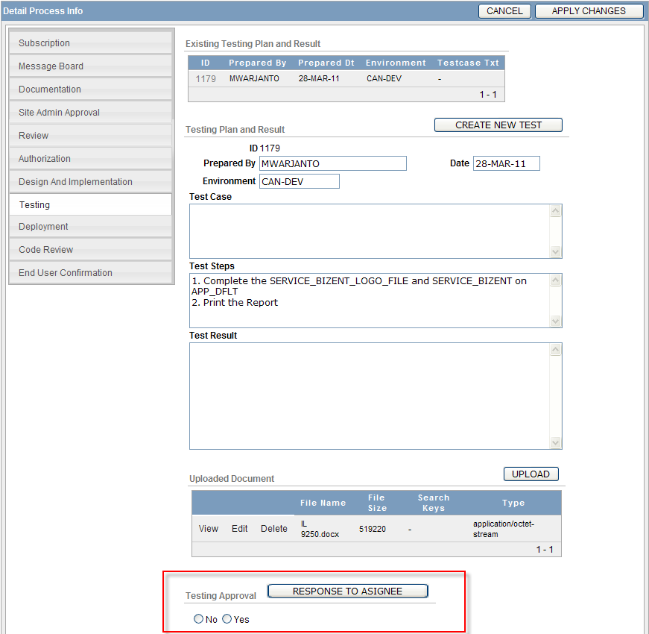

- Other users
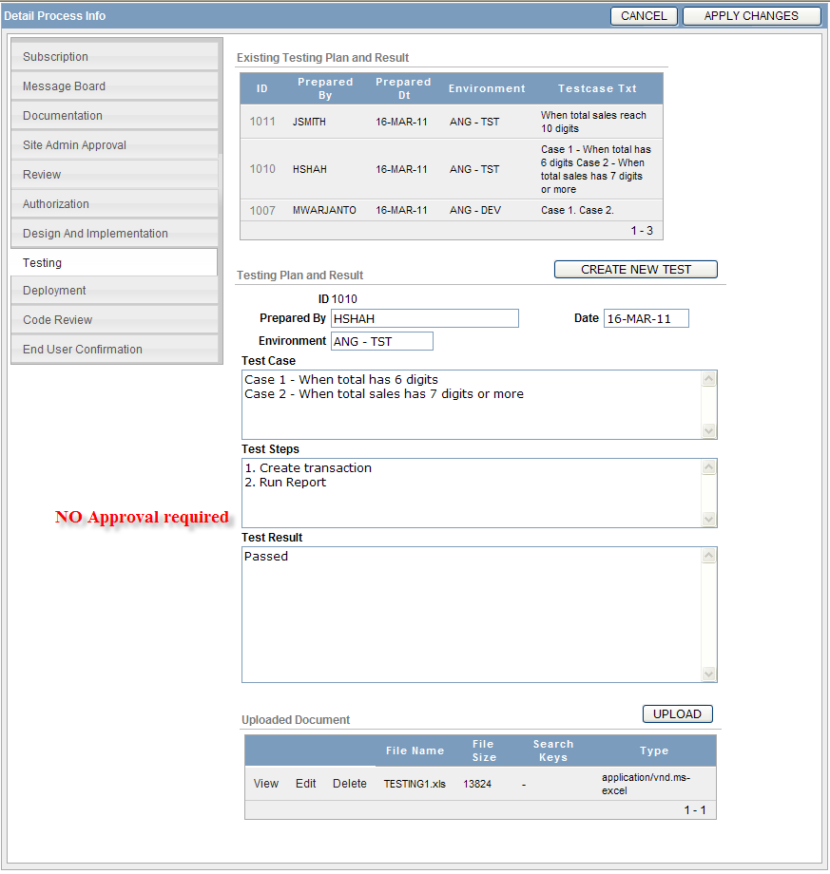

Deployment

This section is accessible only to IT Director and IT Managers. The purpose of this section is to document all the involved deployments: deployment to test and deployment to production. See below figure.

Item

- Deployed to TST checkbox – To indicate if the updated application is available on TEST environment.
- User Testing Notification checkbox – To indicate when end user has been notified if updated application is available on TEST environment.
- Email field – List of end user. It is defaulted to the creator’s email.
- SEND EMAIL button – To send email notification to listed email address.
- IT DIR APPROVAL button – To send email to IT Director ask for his approval to access the PRODUCTION environment.
- Yes/No radio button – To document IT Director’s approval.
- Note
- Deploy By – To document who deploy the application to PRODUCTION environment
- Instruction. Option on the select list is limited to IT Managers’ usernames.
- VERIFICATION REQUEST button – To send email to the other manager (other than the deployer) ask him to do post deployment verification.
- Verify By – To document who performs the verification. Option on the select list is limited to IT Managers’ usernames.
- Result – To document the result of the post deployment verification.
- Note

Instruction

On Deployment to Testing (Completed by Manager) section
- Click the “Deployed to TST” checkbox
- Date field will automatically populated
- Click the APPLY CHANGES button
- Click the “User Testing Notification” checkbox
- Date field will automatically populated
- Email field and SEND EMAIL button will be appeared
- Click the APPLY CHANGES button to save the changes
- Click the SEND EMAIL button to send email to the listed email addresses

On IT Director Approval section
- Complete the Yes/No radio button
- Complete the Note text are is needed
- Click the APPLY CHANGES button
- A notification email will automatically sent to IT Managers

On Deployment to Production section
- Select from the Deploy By select list
- Click the APPLY CHANGES button

On Deployment Verification section
- Select from the Verify By select list
- Click the APPLY CHANGES button

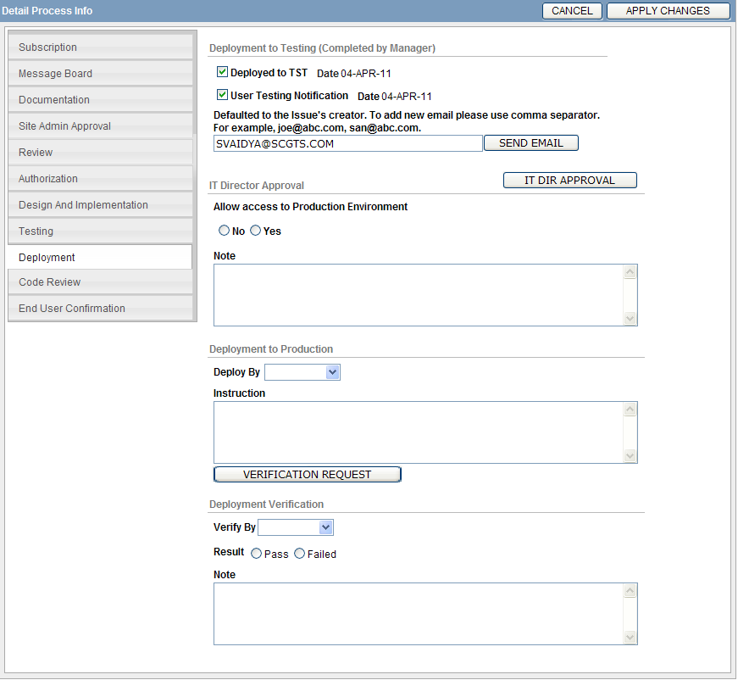

Code Review

This section is only accessible to ISG members. The purpose of this section is to document the result of any code review that is performed on the updated application.

Items

- By – To indicate who performs the review
- Result – To identify what is the result of the review. Options are Pass and Fail
- Note

Instruction
- Complete the necessary fields
- Click the APPLY CHANGES button

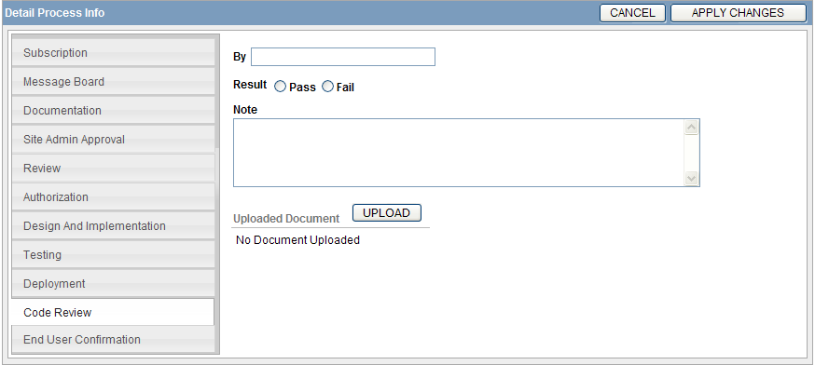

End User Confirmation

This section is accessible by all users except the Guest type of users. The purpose of this section is to document end user’s confirmation of the completed fix on the reported issue.

Items

- By – Name of user who provides the confirmation.
- Date – Automatically populated as soon as the By field is completed.
- Note – Note if available.

Instructions

- Complete the necessary fields
- Click the APPLY CHANGES button



