This document contains information proprietary to Sumitomo Corporation Global Tubular Solutions LLC, and may not be reproduced, disclosed or used in whole or part without the express written permission of Sumitomo Corporation Global Tubular Solutions LLC.
© 2009 Sumitomo Corporation Global Tubular Solutions LLC

Installing ThinForms for XGEN
  - Installation Instructions
Authors: Jeff Garner
Date: 03-MAR-2021
Last Reviewed:
Reviewer:
Location: Houston

Revision History
Revision Number | Revision Date | Revision Author | Revision Approval
1.0 | 21-Feb-2021 | Jeff Garner
1.1 | 03-MAR-2021 | Jeff Garner
1.2 | 09-MAR-2021 | Jeff Garner
1.3 | 24-FEB-2023 | Daniel Gonzalez

Contents
1 Definition 3
2 Prerequisites 3
3 Install ThinApplet Java Host 5
4 Install ThinApplet Chrome Extension 9
5 Configure the Chrome Extension 10
6 Confirm extension works in Chrome Browser 13
7 Install ThinApplet Edge Extension 16
8 Configure the Edge Extension 17
9 Confirm extension works in Edge Browser 19

Definition
The product ThinApplet (ThinForms) by TalkingByte Pty Ltd is a replacement for the JRE (Java Runtime Environment) that is required to run legacy Oracle Forms screens within iTIMS XGEN.
Installation of ThinApplet consists of two main components:
ThinApplet Java Host: This component provides the actual runtime environment for the Oracle Forms applications.
ThinApplet Chrome (or MS Edge) Browser Extension: This component is a browser extension and facilitates the hand-off of browser-based Forms Applets to the main Java Host Runtime.

Prerequisites
Note: All computers that currently are running XGEN ITIMS where ITIMS Legacy forms run successfully via Internet Explorer already have this prerequisite of the Java Runtime Environment installed and can skip to section 3.

Operating Systems currently supported by ThinApplet Chrome Extension are:

- Windows 7
- Windows 8
- Windows 10 up to OS Build 19042.804

Java Runtime Environment 1.7.* or 1.8.*

How to check your current Java version

To check if you already have the correct version installed, please follow the following steps:

- Click on Start and type “cmd” - This should show the “Command Prompt”
- Click on “Open”

- On the command prompt enter:
  - java -version

- If java is installed, you will see a message similar to the one below. If it reads java version “1.7.****” or “1.8.****” then you already have the correct version of java installed.

Note: IF YOU DO NOT HAVE A CORRECT VERSION OF JRE INSTALLED, use the link http://itims2.scgts.com and click on link for ITIMS2 Client Setup and follow the instructions in the opened document “JRE Implementation Guide”.
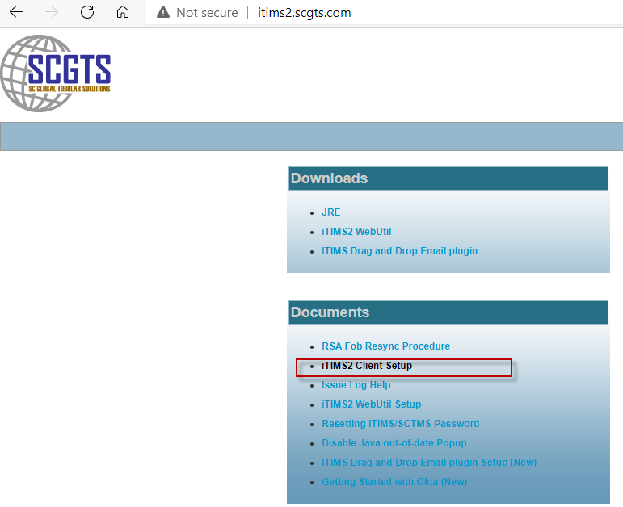

Install ThinApplet Java Host

- Please download the latest version of the ThinApplet Java Host from the http://itims2.scgts.com website by clicking on the link for “ITIMS Chrome Edge browser plugin”:

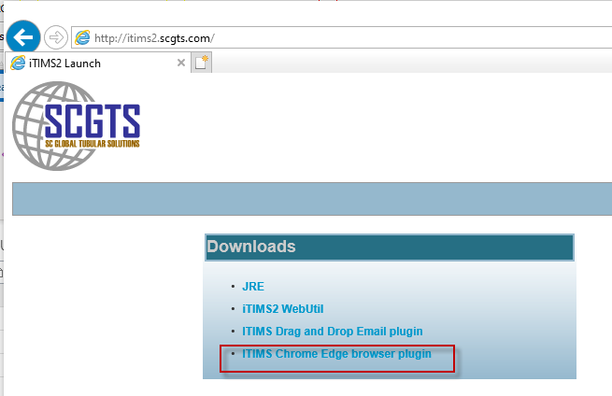

- The downloaded zip file will be called ThinForms_JavaHost_installer.zip.

- Extract the above downloaded ThinForms_JavaHost_installer.zip file into a temporary folder, preferably to the folder c:\temp.

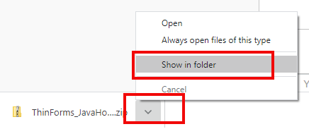

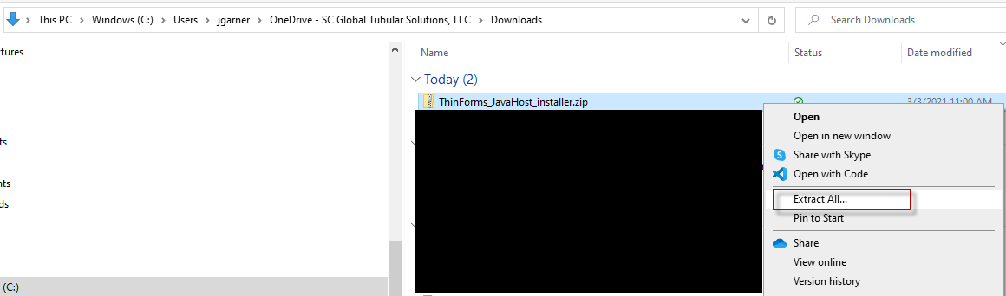

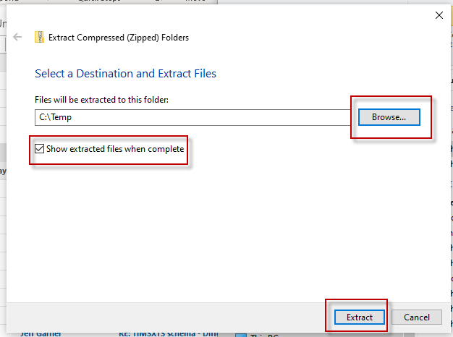

- From the temporary folder where you extracted the zip file to, (ex. c:\temp), start the installer by running the unzipped application file ThinForms_JavaHost_Installer_SCGTS_v6_03a_NoForceClose.exe. Please note that your user will require administrator rights to install the application, so right click on the downloaded file and choose “Run as administrator”.
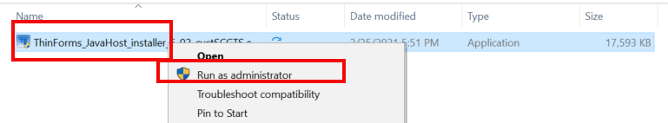
- If you get the following screen, click on More Info link
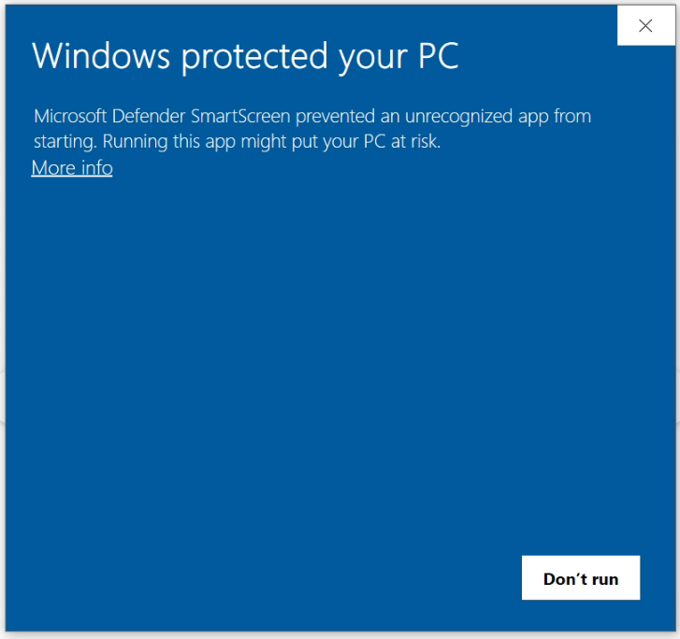
- Click un Run Anyway button
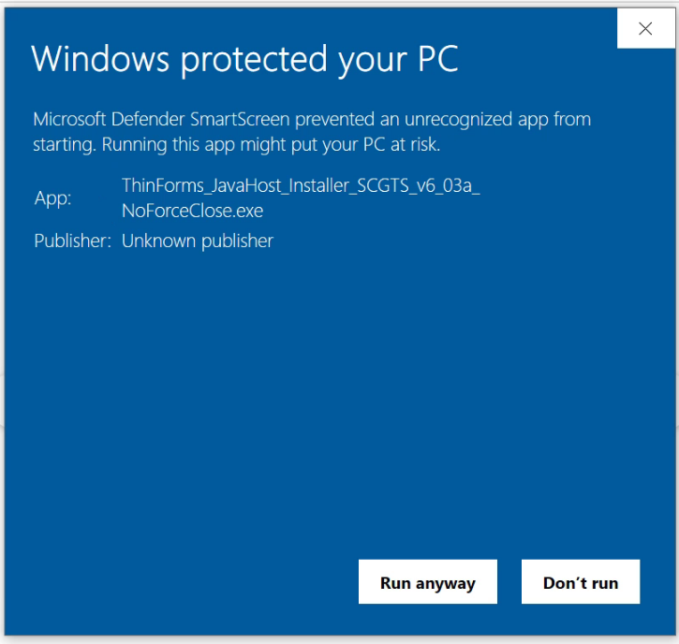
- You may get a User Account Control alert message asking for permissions to make changes to your device. Click on Yes Button
- The installation will be “silent”. You will see a black DOS screen that may show the following message if there are not any Thin Applet or Java programs running at the moment of the installation. No need to worry about these ERROR messages
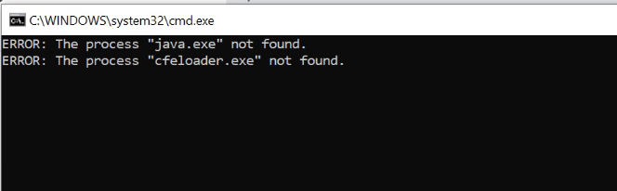
- DOS screen will appear for a few seconds and then it will disappear.

- At this point, the installation of the ThinApplet Java Host is complete; just skip to Section 4, “Install ThinApplet Chrome Extension”. (Note: ignore strikethrough steps 5 through 7 as they are only applicable when then installation is NOT “silent”.)

- You will see the following installation dialog:
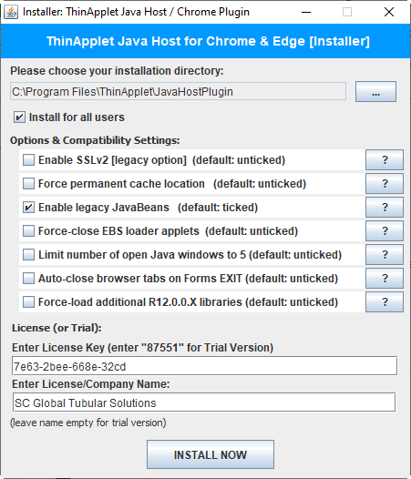

For the License Key, enter: 7e63-2bee-668e-32cd
For the License/Company Name, enter: SC Global Tubular Solutions

- To proceed with the installation, please enter the License Key and the License/Company Name in the appropriate fields and then click on INSTALL NOW to start the installation.

- The installation should take just a few seconds.
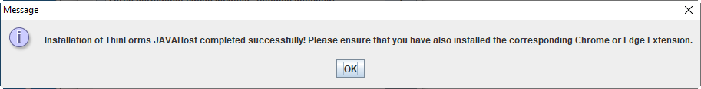

- Once the Java Host has been installed, please proceed with the installation of the ThinApplet Chrome Extension in your browser (or MS Edge browser). Details are below.

Install ThinApplet Chrome Extension
- Open a Chrome Browser window and install the Plugin by pasting the URL https://chrome.google.com/webstore/detail/thinforms-enterprise-for/nmjefghbgfcpoobigfbalocpncklkjhk

- Add the PlugIn to Chrome by clicking the “Add to Chrome” button and the “Add Extension”.
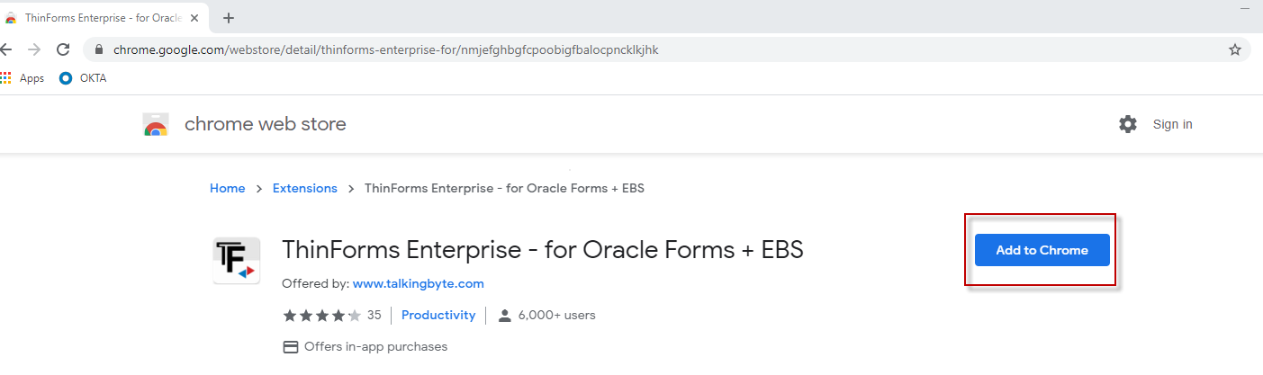

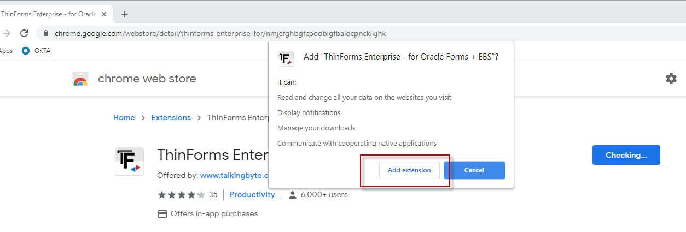
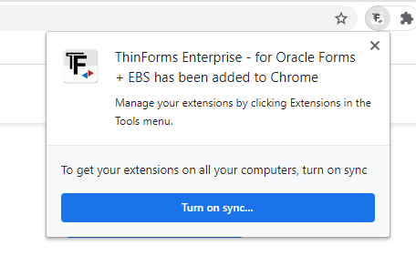
ThinApplet Brower Extension Installation Complete for Chrome Browser

Configure the Chrome Extension
- Now we need to configure the ThinForms PlugIn in Chrome. Click the 3 vertical dots at top right of the Chrome browser, then click More Tools, and then Extensions.
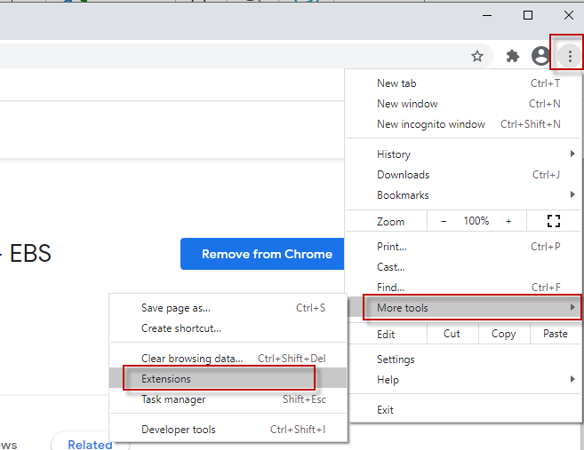

- Find the extension for “ThinForms Enterprise…” and click “Details”. On the popup, scroll down and click “Extension Options”.
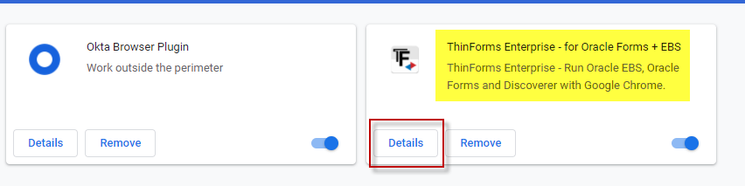
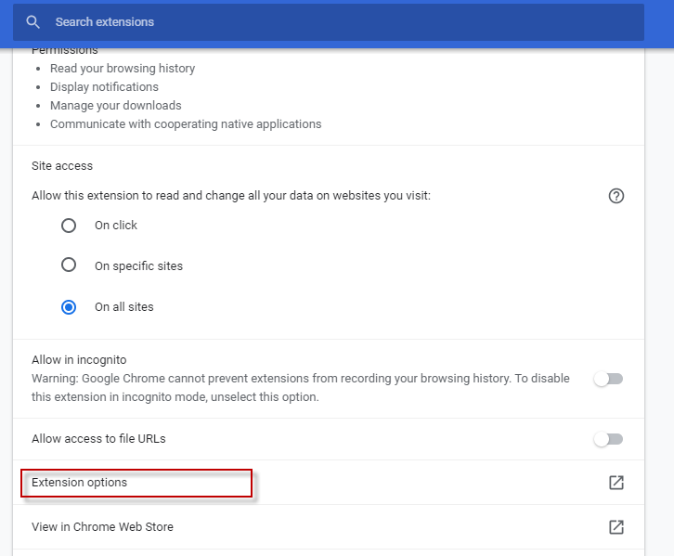

- Next, click the option “Close Browser Tab on Forms Disconnect” and the click “Save Settings”.
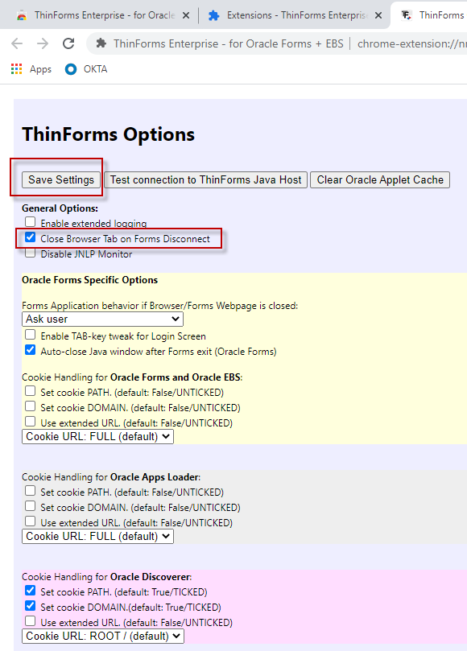

- Now exit the Chrome Browser.

Confirm extension works in Chrome Browser
- Start a Fresh Chrome Browser window and launch ITIMS XGEN from OKTA.

- Once in XGEN, launch the Legacy screen Invoice from the Sales Menu.
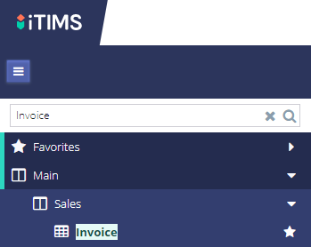

- You will see a small Chrome window appear on the screen behind or to the left of the running legacy form.
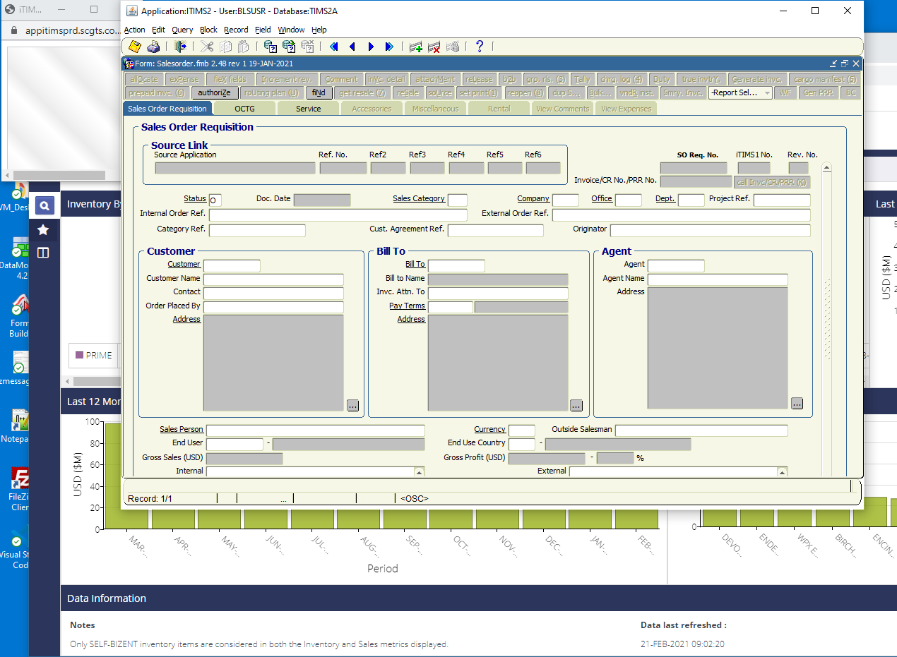

- If you see the Legacy ITIMS form, the install has been successful.

- Now let’s run a report from an ITIMS Legacy Form. Go to any ITIMS Legacy form that has a report on the “Report Selection” toolbar item and run the report. We are going to make sure the “pop-up blocker” is disabled in the Chrome browser. This example will show a report from the INVC legacy screen.
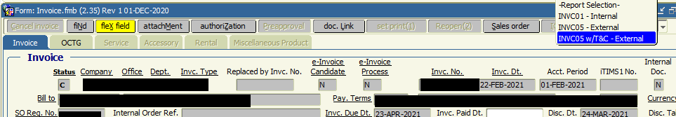
- The report will launch in a tab on the Chrome browser and the Parameter screen will be displayed temporarily and the report should automatically run.
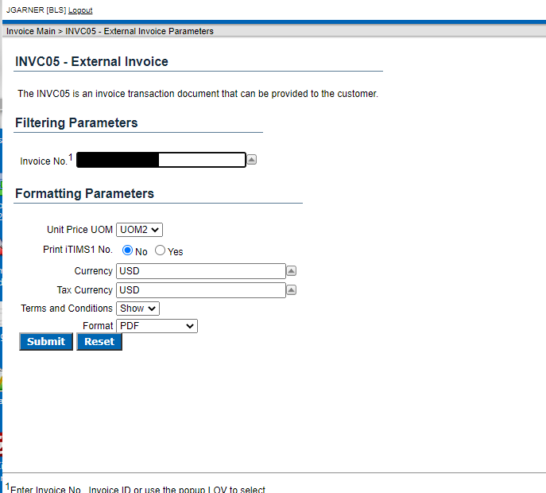
- The report should be displayed on an “rwservlet“ popup.
  - If the report does NOT pop up, check the URL bar to see if there is a “pop up blocker” enabled (should be shown in red). If so, click on the “pop up blocker” and follow the prompts to always allow popups from “this” site.
  - Note: This will need to be done for both TEST and PRODUCTION.
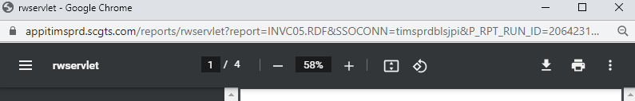
- ThinForms for Chrome browser installation and setup is complete.

Install ThinApplet Edge Extension
- Open a Microsoft Edge Browser window (Chromium version) and install the Plugin by pasting the URL https://microsoftedge.microsoft.com/addons/detail/thinforms-enterprise-fo/oglecbijmgapljhhgeiiokjlimekelbk

- Add the PlugIn to Edge by clicking the “Get” button and the “Add Extension”.

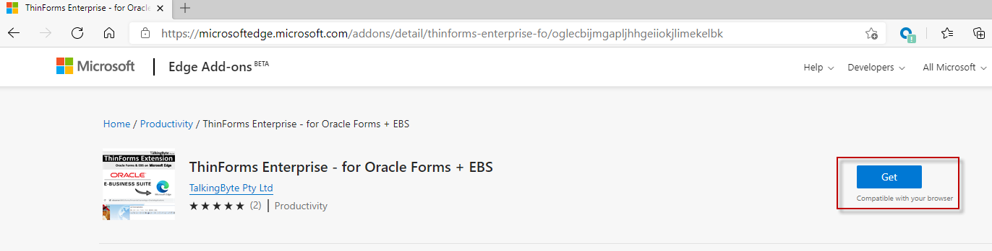

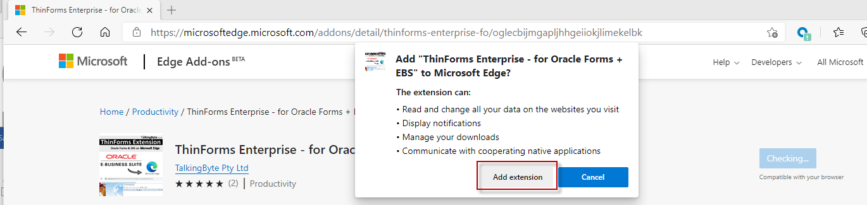

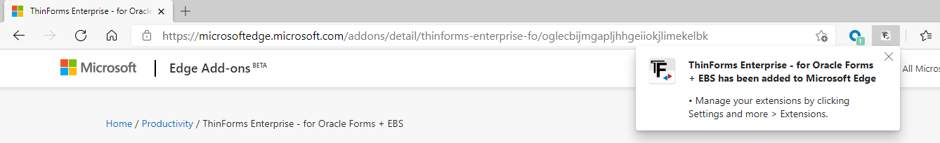

ThinApplet Brower Extension Installation Complete for Edge Browser

Configure the Edge Extension
- Now we need to configure the ThinForms PlugIn in Edge. Click the 3 vertical dots at top right of the Edge browser, then click Extensions.
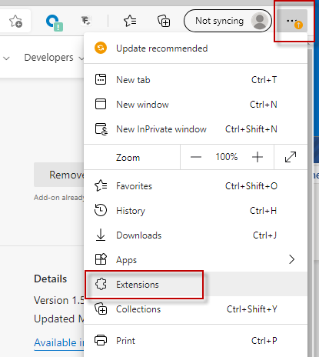

- Find the extension for “ThinForms Enterprise…” and click “Details”. On the popup, scroll down and click “Extension Options”.

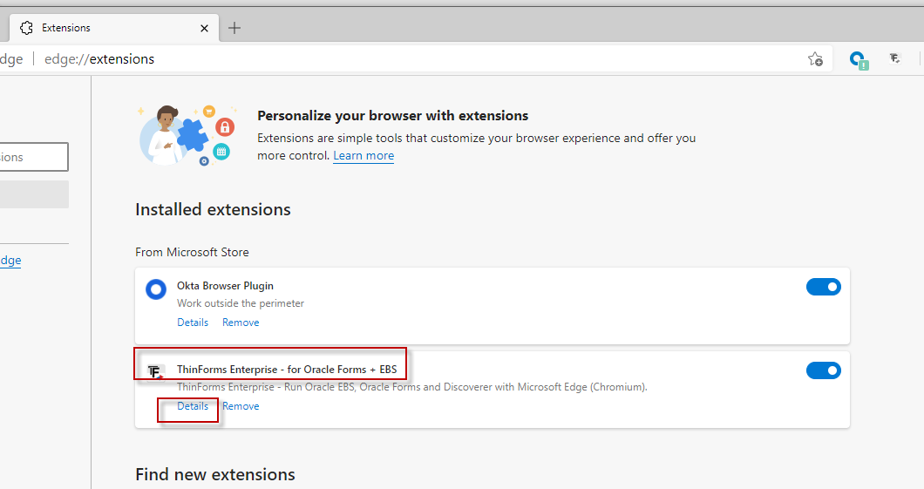

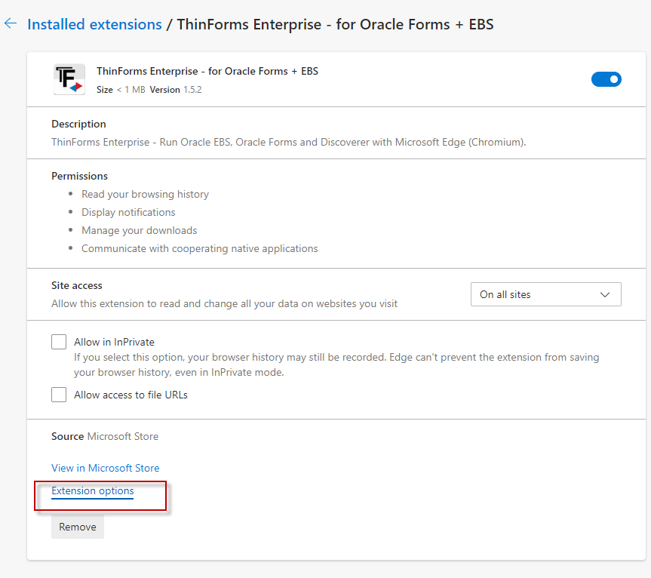
- Next, click the option “Close Browser Tab on Forms Disconnect” and the click “Save Settings”.
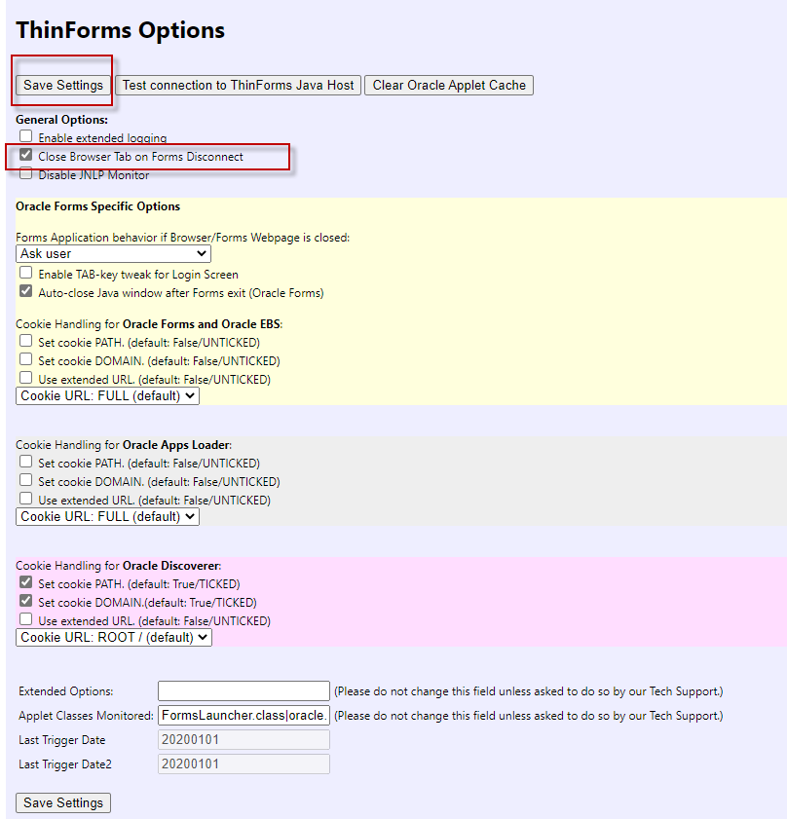
- Now exit the Edge Browser.

Confirm extension works in Edge Browser
Follow the same steps in section 6, “Confirm Extension works in Chrome Browser”, as they are the same for Microsoft Edge.

END OF DOCUMENT.

