This document contains information proprietary to Sumitomo Corporation Global Tubular Solutions LLC, and may not be reproduced, disclosed or used in whole or part without the express written permission of Sumitomo Corporation Global Tubular Solutions LLC.
© 2009 Sumitomo Corporation Global Tubular Solutions LLC

iTIMS2 and SCTMS Password Reset
Authors: Alex Addington
Date: 22-Jun-16
Last Reviewed:
Reviewer:
Location: Houston, TX

Revision History
Revision Number | Revision Date | Revision Author |  | Revision Approval
1.0 | 22-Jun-16 |  | Alex Addington

Contents
1 Objective 3
2 Password Reset Process 3
2.1 Set Up Challenge Questions 3
2.2 Resetting Password 6
2.3 Confirmation 7
3 Contacts 7

Objective
The objective of this document is to show users how to reset their password and set up challenge questions for iTIMS2 and SCTMS.

Password Reset Process

Set Up Challenge Questions
Users can access the Identity Self Service Portal by way of http://oim.scgts.com/identity. The User ID and Password are the same as your iTIMS2 or SCTMS login.
Note: If the user has multiple accounts to login into ITIMS/SCTMS, they will have to follow the below steps for all their individual accounts.
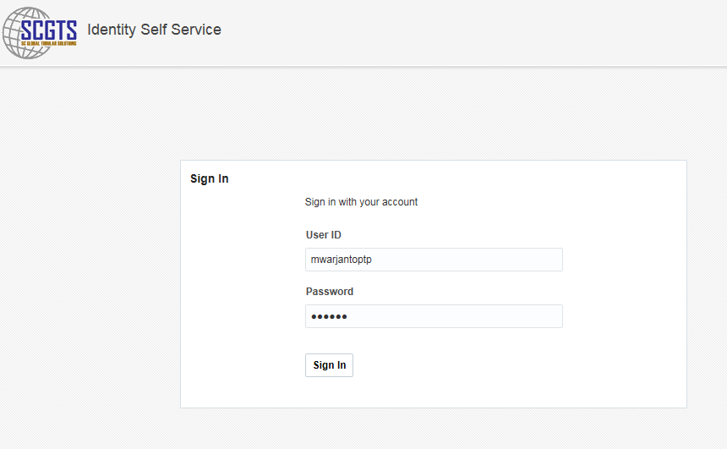

After successfully logging in, users will be brought to the home screen. From here, they will click the My Information icon (shown below).
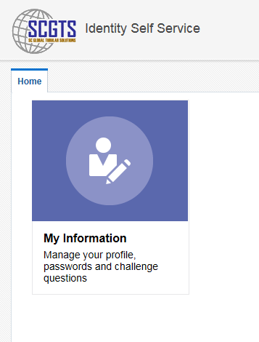
Users are then brought to the My Information page. At the bottom of the page, you will see your name with two expandable categories underneath. First, expand the Challenge Questions section. Users will select and answer 3 standard security questions. These include:
- What is the city of your birth?
- What is your favorite color?
- What is the name of your pet?

Once users have completed the 3 questions and answers, and clicked out of the text boxes, users can then click the Apply button that is highlighted in green.

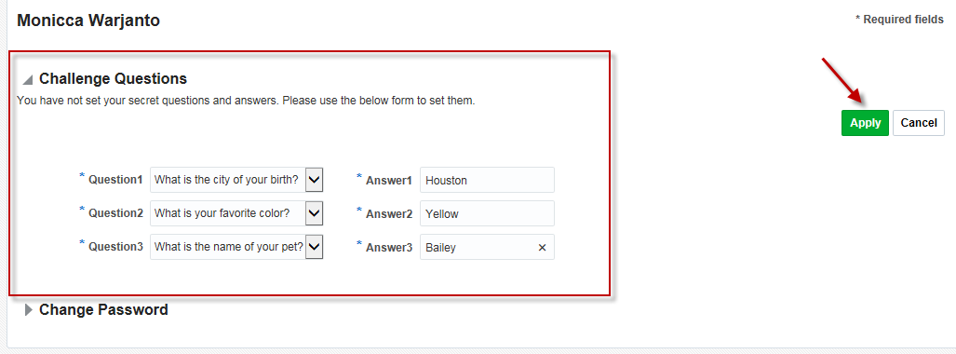

Once Apply is clicked, you will see a success message in the top, left-hand corner of your screen. Your answers to the challenge questions will disappear, but are stored by the system.
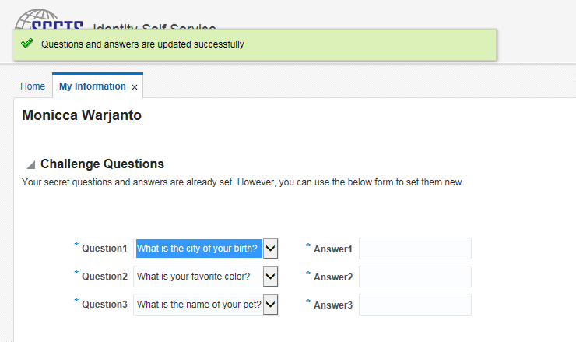

Resetting Password
On the My Information page, users need to expand the Change Password section, located at the bottom of the page (directly under the Challenge Questions section). There are 3 required fields in this section:
- Old Password
- New Password
- Confirm New Password

New passwords must meet the following criteria:

- Cannot be one of you last 5 used passwords
- Must meet the minimum length of 6 characters
- Must include a minimum 1 numeric character
- Password must not match or contain last name
- Password must not match or contain user ID

Once you have entered the information that meets the criteria and the user is clicked out of the text box, you can click the Apply button that is highlighted in green.

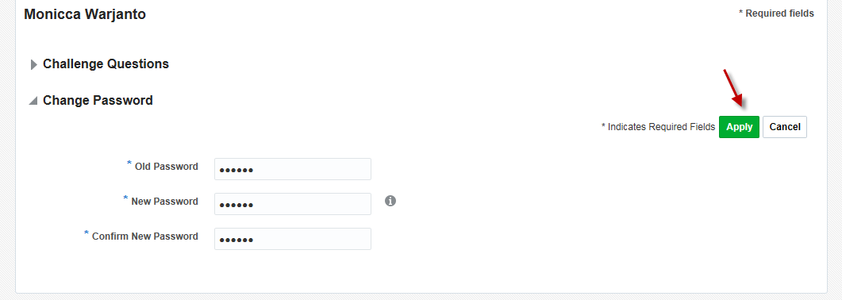

Once Apply is clicked, you will see a success message in the top, left-hand corner of your screen. The values you entered will disappear from the page, but will be stored by the system.

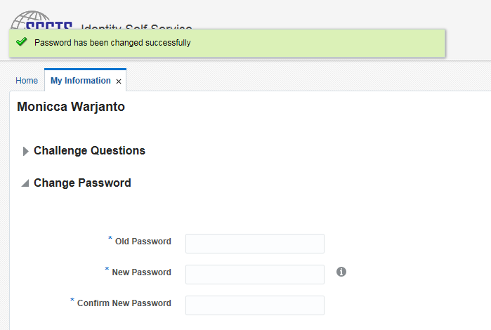

Confirmation
After completing the password change, please log in to the iTIMS2 or SCTMS application using your new, updated password. Users can access the system with the following link https://itims2.scgts.com.

Contacts
Please contact the SCGTS Helpdesk at helpdesk@scgts.com with any questions or issues.

